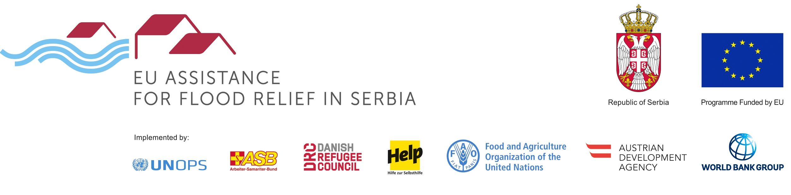

PROGRAMME: REHABILITATION OF FLOOD PROTECTION INFRASTRUCTURE
TENDER: SUPERVISION OF RIVER REGULATION WORKS IN VALJEVO, PARACIN AND SVILAJNAC
REFERENCE: RFPI 015 2016

The Austrian Development Agency (acting on behalf of the public water management company Srbijavode as Investor) intends to award a service contract for the supervision of works under FIDIC contract conditions in Valjevo, Paraćin and Svilajnać with financial assistance from the European Union. The open tender procedure is conducted pursuant to the provisions of the Austrian Federal Act on Public Procurement (Bundesvergabegesetz).

The official tender notice is published on: https://www.auftrag.at/eTender.aspx?id=9B1F5434-0026-463C-961E-DDBDBA8A6272&action=show . The tender dossier can be downloaded under this link after registration. Possible additional information, addenda or clarifications shall be published on:
https://www.auftrag.at/eTender.aspx?id=9B1F5434-0026-463C-961E-DDBDBA8A6272&action=show

Contact Point/further information: WOLF THEISS Rechtsanwälte, Vienna
E-mail: supervision.vsp@wolftheiss.com, Fax: + 43 1 515 10 665354
Location of the works: Valjevo, Paraćin and Svilajnać in Serbia.
CPV codes: 71520000, 71521000
Deadline for submission of tenders: 1 February 2017, 11:00 a.m at WOLF THEISS Rechtsanwälte GmbH & Co KG, Schubertring 6, 1010 Vienna, Austria.
Opening of tenders: 1 February 2017, 11:30 a.m. at WOLF THEISS Rechtsanwälte, Schubertring 6, 1010 Vienna, Austria.

